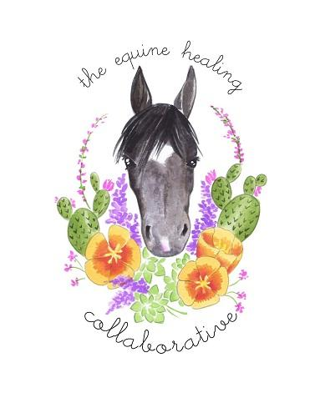

Equine Assisted Psychotherapist
The Equine Healing Collaborative
a 501(c)(3) nonprofit

Job Description

Position Title: Equine Assisted Psychotherapist/Clinician

We accept applications from the following clinicians: LMFT, LCSW, AMFT, ACSW, MFT trainees, and CSW trainees.

EHC Mission:
The EHC was created to provide a path to recovery, self-discovery, and personal growth through the use of Equine Assisted Psychotherapy. Clinical staff play a vital role in assisting the EHC in meeting its mission. The role of clinician is to gently guide clients along a personal path, helping them heal, regain personal strength, and find happiness.

Key Clinical Responsibilities:
- Maintain and provide weekly therapy sessions for a minimum of ten clients.
- Act in accordance with professional ethics and legal responsibilities, including following mandated reporting laws, maintaining confidentiality, and electronic medical records.
- Remain in good standing with the California Board of Behavioral Sciences and keep current personal liability insurance.
- Commit to at least two years of clinical work at the EHC.
- Attend weekly group and individual supervision regardless of licensure status.
- Attend all mandatory training and quarterly staff meetings.

Key Equine Responsibilities:
- Tend to and prioritize our equine partners’ social and emotional needs.
- Groom each equine during every EAP session, including picking feet.
- Participate in at least three months of training prior to seeing clients.

Physical Demands and Working Environments:
- The ability to lift 50 pounds regularly
- The ability to respond quickly to sounds and movements
- The ability to move safely over uneven terrain or in confined spaces in all weather conditions
- The ability to traverse up and down an incline over uneven terrain
- The ability to see, respond to, and move away from dangerous situations
- The ability to pull or push 100 lbs 5 feet
- The ability to work in outdoor weather conditions
- The ability to regularly position oneself to clean a horse’s feet, squatting and bending over while safely holding the horse’s foot

COVID-19 Response:
Pursuant to California Health and Safety Code sections 120125, 120140, 120175, 120195, and 131080, all health care workers must be vaccinated to reduce the chance of transmission to vulnerable populations. Proof of current vaccination must be provided at the time of application, and upon further request from the EHC.
All activities are held outdoors and employees are required to maintain a minimum 3 feet distance from others.

Qualifications

- Maintain “Associate” or “Licensed” status by the California Board of Behavioral Sciences or be actively enrolled as a “Trainee” in a BBS approved graduate studies program in pursuit of licensure.
- Register and maintain a current CAQH ProView account.
- Hold personal professional liability malpractice insurance.

Training and Probationary Periods

- All clinicians must commit to a minimum 3 months of horse-handling training and EAP training prior to seeing clients.
- LMFT, LCSW, AMFT, and ACSW clinicians must commit to an additional 6 months of volunteer/probationary work in which they maintain a minimum caseload of 5 clients prior to being compensated for services.

